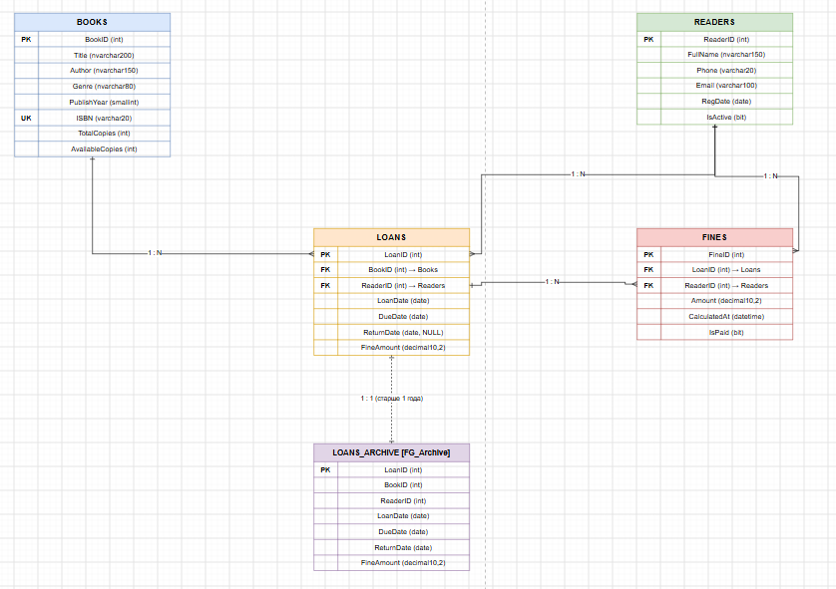
РОЛИ
-- ============================================
-- СОЗДАНИЕ РОЛЕЙ
-- ============================================
CREATE ROLE Admin;
CREATE ROLE Librarian;
CREATE ROLE ReaderRole; -- "Reader" зарезервировано в SQL Server
CREATE ROLE InventoryManager;
GO

-- ============================================
-- Admin — полный доступ (db_owner)
-- ============================================
ALTER ROLE db_owner ADD MEMBER Admin;
GO

-- ============================================
-- Librarian — INSERT/UPDATE/SELECT на Loans и Reader;
-- SELECT на Books; без DELETE на Books
-- ============================================
GRANT SELECT, INSERT, UPDATE ON Loans TO Librarian;
GRANT SELECT, INSERT, UPDATE ON Reader TO Librarian;
GRANT SELECT ON Books TO Librarian;

DENY DELETE ON Books TO Librarian; -- явный запрет удаления книг
DENY SELECT, INSERT, UPDATE, DELETE ON FINES TO Librarian;
DENY SELECT, INSERT, UPDATE, DELETE ON LoansArchive TO Librarian;
GO

-- ============================================
-- ReaderRole — SELECT только на Books
-- и свои записи о выдачах (через VIEW)
-- ============================================

-- Представление: только свои займы (фильтр по SESSION_USER или ReaderID)
CREATE VIEW vMyLoans AS
SELECT l.LoanID, b.Title, l.LoanDate, l.DueDate, l.ReturnDate, l.FineAmount
FROM Loans l
JOIN Books b ON l.BookID = b.BookID
WHERE l.ReaderID = CAST(SESSION_CONTEXT(N'ReaderID') AS INT);
GO

GRANT SELECT ON Books TO ReaderRole;
GRANT SELECT ON vMyLoans TO ReaderRole;

DENY SELECT, INSERT, UPDATE, DELETE ON Loans TO ReaderRole;
DENY SELECT, INSERT, UPDATE, DELETE ON Reader TO ReaderRole;
DENY SELECT, INSERT, UPDATE, DELETE ON FINES TO ReaderRole;
DENY SELECT, INSERT, UPDATE, DELETE ON LoansArchive TO ReaderRole;
GO

-- ============================================
-- InventoryManager — INSERT/UPDATE/DELETE на Books;
-- DENY на Loans и Reader
-- ============================================
GRANT SELECT, INSERT, UPDATE, DELETE ON Books TO InventoryManager;

DENY SELECT, INSERT, UPDATE, DELETE ON Loans TO InventoryManager;
DENY SELECT, INSERT, UPDATE, DELETE ON Reader TO InventoryManager;
DENY SELECT, INSERT, UPDATE, DELETE ON FINES TO InventoryManager;
DENY SELECT, INSERT, UPDATE, DELETE ON LoansArchive TO InventoryManager;
GO

ГОТОВАЯ НЕЙРО БД
USE Bublioteka;
GO

-- ============================================
-- 1. ТАБЛИЦА BOOKS
-- ============================================
CREATE TABLE Books (
BookID INT PRIMARY KEY IDENTITY(1,1),
Title VARCHAR(100) NOT NULL,
Author VARCHAR(100) NOT NULL,
Genre VARCHAR(100) NOT NULL,
PublicationYear SMALLINT NOT NULL,
ISBN VARCHAR(20) UNIQUE NOT NULL,
TotalCopies INT NOT NULL DEFAULT 0,
AvailableCopies INT NOT NULL DEFAULT 0
) ON FG_Bublioteka;
GO

-- Индексы Books — все на основной файловой группе
CREATE NONCLUSTERED INDEX IX_Books_Author
ON Books (Author) ON FG_Bublioteka;

CREATE NONCLUSTERED INDEX IX_Books_Genre
ON Books (Genre) ON FG_Bublioteka;

CREATE NONCLUSTERED INDEX IX_Books_PublicationYear
ON Books (PublicationYear) ON FG_Bublioteka;

CREATE NONCLUSTERED INDEX IX_Books_Title
ON Books (Title) ON FG_Bublioteka;
GO

-- ============================================
-- 2. ТАБЛИЦА READER
-- ============================================
CREATE TABLE Reader (
ReaderID INT PRIMARY KEY IDENTITY(1,1),
FullName VARCHAR(100) NOT NULL,
PhoneNumber VARCHAR(20) NOT NULL
CHECK (PhoneNumber LIKE '+7%' AND PhoneNumber NOT LIKE '%[^0-9+]%'),
Email VARCHAR(100) NULL,
RegDate DATE NOT NULL DEFAULT GETDATE(),
IsActive BIT NOT NULL DEFAULT 1
) ON FG_People;
GO

CREATE NONCLUSTERED INDEX IX_Reader_PhoneNumber
ON Reader (PhoneNumber) ON FG_People;

CREATE NONCLUSTERED INDEX IX_Reader_Email
ON Reader (Email) ON FG_People;
GO

-- ============================================
-- 3. ТАБЛИЦА LOANS
-- ============================================
CREATE TABLE Loans (
LoanID INT PRIMARY KEY IDENTITY(1,1),
BookID INT NOT NULL,
ReaderID INT NOT NULL,
LoanDate DATE NOT NULL DEFAULT GETDATE(),
DueDate DATE NOT NULL,
ReturnDate DATE NULL,
FineAmount MONEY DEFAULT 0,
CONSTRAINT FK_Loans_Books FOREIGN KEY (BookID) REFERENCES Books(BookID),
CONSTRAINT FK_Loans_Reader FOREIGN KEY (ReaderID) REFERENCES Reader(ReaderID)
) ON FG_Indexes;
GO

CREATE NONCLUSTERED INDEX IX_Loans_BookID
ON Loans (BookID) ON FG_Indexes;

CREATE NONCLUSTERED INDEX IX_Loans_ReaderID
ON Loans (ReaderID) ON FG_Indexes;

-- Фильтрованный индекс только для активных (невозвращённых) займов
CREATE NONCLUSTERED INDEX IX_Loans_Active
ON Loans (DueDate, ReaderID)
WHERE ReturnDate IS NULL
ON FG_Indexes;
GO

-- ============================================
-- 4. ТАБЛИЦА LOANS_ARCHIVE (на FG_Archive)
-- ============================================
CREATE TABLE LoansArchive (
LoanID INT PRIMARY KEY,
BookID INT NOT NULL,
ReaderID INT NOT NULL,
LoanDate DATE NOT NULL,
DueDate DATE NOT NULL,
ReturnDate DATE NULL,
FineAmount MONEY DEFAULT 0
) ON FG_Archive; -- <-- исторические данные старше 1 года
GO

CREATE NONCLUSTERED INDEX IX_LoansArchive_ReaderID
ON LoansArchive (ReaderID) ON FG_Archive;

CREATE NONCLUSTERED INDEX IX_LoansArchive_LoanDate
ON LoansArchive (LoanDate) ON FG_Archive;
GO

-- ============================================
-- 5. ТАБЛИЦА FINES
-- ============================================
CREATE TABLE FINES (
FineID INT PRIMARY KEY IDENTITY(1,1),
LoanID INT NOT NULL,
ReaderID INT NOT NULL,
Amount MONEY NOT NULL,
CalculatedAt DATETIME NOT NULL DEFAULT GETDATE(),
IsPaid BIT NOT NULL DEFAULT 0,
CONSTRAINT FK_Fines_Loan FOREIGN KEY (LoanID) REFERENCES Loans(LoanID),
CONSTRAINT FK_Fines_Reader FOREIGN KEY (ReaderID) REFERENCES Reader(ReaderID)
) ON FG_Indexes;
GO

CREATE NONCLUSTERED INDEX IX_Fines_LoanID
ON FINES (LoanID) ON FG_Indexes;

CREATE NONCLUSTERED INDEX IX_Fines_ReaderID_IsPaid
ON FINES (ReaderID, IsPaid) ON FG_Indexes;
GO

1))))
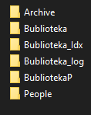
2)))))

